**REAL-TIME COMMUNICATION SYSTEM POWERED BY AI FOR SPECIALLY ABLED**

SOLUTION ARCHITECTURE

# PROBLEM STATEMENT:

* **Statement –** In the recent years, there has been rapid increase in the number of deaf and dumb victims due to birth defects, accidents and oral diseases. Since deaf and dumb people cannot communicate with normal person so they have to depend on some sort of visual communication. A World Health Organization report says around 63 million people in India suffer from either complete or partial deafness, and of these, at least 50 lakh are children. Communication between deaf-mute and a normal person has always been a challenging task.
* **Description -** The Deaf/Dump people needs a way to communicate easily and quickly with the normal people, so that the Deaf/Dump people feel confident enough to express there thought, ideas, and can make conversation with the normal people.

# SOLUTION ARCHITECTURE:

* **Solution**

The project aims to develop a system that converts the sign language into a human hearing voice or text in the desired language to convey a message to normal people, as well as convert speech or text into understandable sign language for the deaf and dumb.

Train data

Image

Neural

Dataset

network

WEB CAM

User

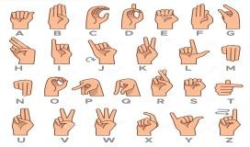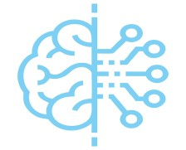

MODEL

Image

Evaluation

processing



Test data

Output Prediction

## Team ID : PNT2022TMID29964

* Team Size : 4

## Team Leader : ARSHAD

## Team member : SUDHARSAN S Team member : MANIKANDAN Team member : SATHISH S

THANK YOU